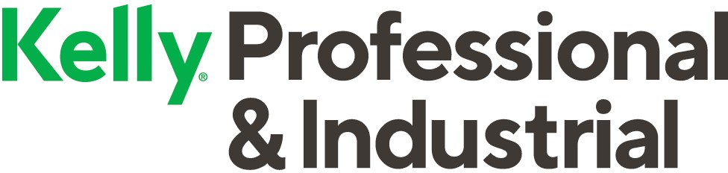

We know job searching can feel like a full-time job with a never-ending checklist. But what if you could work with someone who cares about finding a job that truly fits you? That’s what we’re all about. Right now, we’re hiring for a Leading Health Insurance Company in Jacksonville, IL

Now hiring: Claim Technician

Why you’d want to work here:
- Temp to Hire
- Starting pay $16.50/hr. (once hired $17.20/hr. w/benefits)
- Paid Training On- Site first 8 weeks plus
- Training hours: Mon-Fri 8am -4:30pm
- After Training: Flex hours and hybrid rotation
- Some more perks:
- Kelly® -sponsored ACA health care coverage available to eligible employees
- Individual insurance options*
- Service bonus and holiday pay plans
- Weekly electronic pay options
- Employee assistance program available at no cost

Sound right for you? Apply now!
Julie Seager
Professional Recruiter
Email juls367@kellyservices.com or
Text 517.803.2219
OR use the QR Code below to apply directly!
pi.kellyservices.us
*Offered and administered by a third-party vendor. These plans are not sponsored by Kelly. An Equal Opportunity Employer © 2021 Kelly Services, Inc. All rights reserved.

